**CA4006: Concurrent Java Elevator Simulation**

Alex Randles: 15302766

Kealan Thompson: 12417338

Declaration on Plagiarism

Assignment Submission Form

This form must be filled in and completed by the student(s) submitting an assignment

Name(s): Alex Randles, Kealan Thompson

Programme: CASE

Module Code: CA4006

Assignment Title: The Elevator Problem

Submission Date: 22/03/19

Module Coordinator: Rob Brennan, Martin Crane

I/We declare that this material, which I/We now submit for assessment, is entirely my/our

own work and has not been taken from the work of others, save and to the extent that such

work has been cited and acknowledged within the text of my/our work. I/We understand

that plagiarism, collusion, and copying are grave and serious offences in the university and

accept the penalties that would be imposed should I engage in plagiarism, collusion or

copying. I/We have read and understood the Assignment Regulations. I/We have identified

and included the source of all facts, ideas, opinions, and viewpoints of others in the

assignment references. Direct quotations from books, journal articles, internet sources,

module text, or any other source whatsoever are acknowledged and the source cited are

identified in the assignment references. This assignment, or any part of it, has not been

previously submitted by me/us or any other person for assessment on this or any other

course of study.

I/We have read and understood the referencing guidelines found at

http://www.dcu.ie/info/regulations/plagiarism.shtml , https://www4.dcu.ie/students/az/plagiarism

and/or recommended in the assignment guidelines.

Name(s): Alex Randles, Kealan Thompson_____________ Date: ___22/03/19_________

**How to run and compile?**

* Compiling



* Running

There are 5 different main methods available that stimulate different scenarios within our system.

**-Stimulate a normal run with 100 random people (Main.java)**

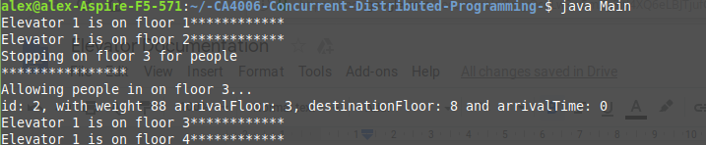

**- Stimulate an overweight elevator (MainWeight.java)**



When the elevator becomes overweight the following will be printed:

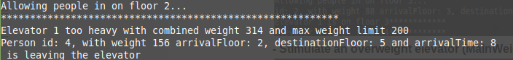

**- Stimulate a fault (MainFault.java)**



When a fault occurs the following will be printed and all the people currently waiting or in the elevator will be transferred to another elevator.

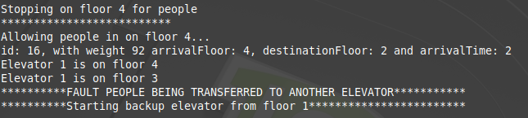

**-Multiple elevators (MainMultipleElevators.java)** 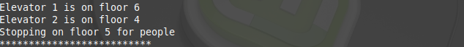

**-Using the elevator simulator GUI (MainGUI.java)**



This will create a GUI that will illustrate the functionality of our code. People are will be moved in and out of the elevator accordingly.

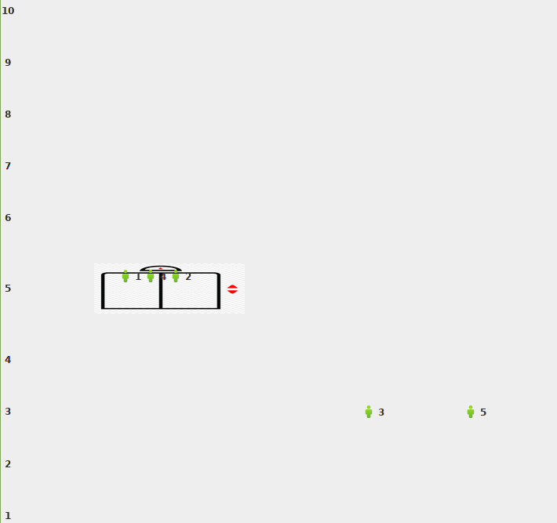

* Output Files

**-Request.dat**

This file contains all the request the elevator has received and includes all the

information relating to themselves and their request.

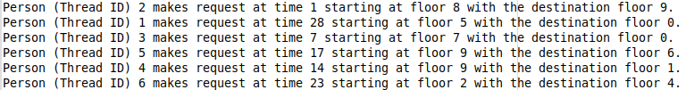

**-Output.dat**

This contains all the output from the actions of the elevator such as which

floor it's on, it's going to and who is entering and leaving the elevator. 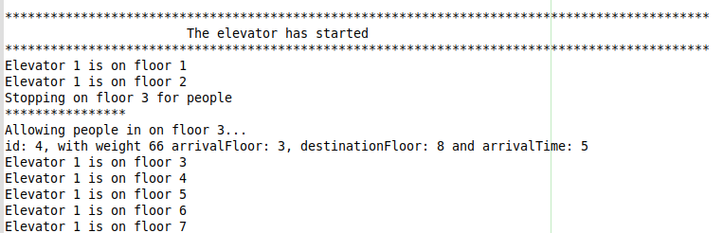

The design

* **Person thread ->** Person.java contains all the variables relating to the person and when the thread is run it will make a request to the elevator controller
* **Elevator Thread ->** Elevator.java runs through the actions of the elevator controller such as changeFloor, stop at floors and allow people in and out.
* **ElevatorController class ->** ElevatorController.java will control the actions of the elevator such as which direction is goes when it lets people in and out. This class has three queues: request (people who have requested the elevator), waiting (people who are currently waiting on their arrival floor) and inElevator (people who are currently in the elevator).Through the use of synchronized methods and push and pop methods the people and elevator are moved around.
* **ElevatorControllerGUI ->**. ElevatorControllerGUI.java is an elevator controller with a GUI.
* **Main Method ->** Main.java this controls the interaction between the person and elevator threads. This will create 100 random people and pass them through our system.
* **Main with fault ->** MainFault.java, this will create a fault within the a random time between 1 - 10 and stop the current elevator thread, a new elevator will be started and all people in the old elevators queues will be transferred over in order.
* **Main with heavy people ->** MainWeight.java will create heavier than normal people to show that the elevator registers weight. The person that makes it overweight will exit the elevator at the floor they go on and will be put at the front of that queue.
* **Main with multiple elevators ->** MainMultipleElevators.java this will stimulate two elevators working at the same time.
* **Main with GUI ->**  MainGUI.java will initialize a ElevatorControllerGUI instance and a display will pop up showing the people and their corresponding ID within the program moving within the elevator system.

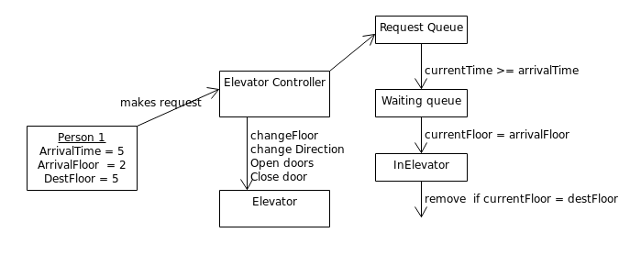

* The above diagram outlines the basic functionality of our solution. A Main class orchestrates the program, creating person objects which are assigned an arrival time, floor, destination floor and weight randomly. The person object then makes a request to the elevator controller which monitors the functions of the elevator. Transferring people who have yet to arrive to a requests queue, those who have arrived to a waiting queue and picking up the passengers from the waiting queue of the current floor.

Our solution uses a combination of concurrent hash maps and concurrent linked queues to implement this design concurrently. With a concurrent hash map representing the request, waiting and in elevator queues. Mapping an integer to a concurrent linked queue of person objects.

**Addressing issues**

* **Fairness ->** Person threads with a smaller arrival arrival time and closer to the elevators current floor will get chosen first. If two people have the same arrival time whoever is closer to the elevators current floor and in the same direction that its currently going will be picked first similar to a normal elevator.
* **Prevention of starvation ->** The elevator will not sleep until all current request are fulfilled, when this is achieved the elevator will sleep until further request are made.

**Assumptions**

* If the elevator direction is up but there are no current request from floors above it will begin to go down.
* The elevator will print what floor its on but it’ll skip any floors that don’t have people seeking to enter or exit the elevator

**Dividing Workload**

* In order to work on this project simultaneously we set up a git repository, planned out our approach and divided up the workload. With both of us working on seperate basic functionality, then combining our work and working together to get the simulator to behave as expected.